**Report on SOAP Webservice**

I have created my own SOAP web service using C#. I created service for converting temperatures from Celsius to Fahrenheit and from Fahrenheit to Celsius. The screenshots are included.

1. The code for the web service is shown below in .cs , .config and in .asmx extensions.

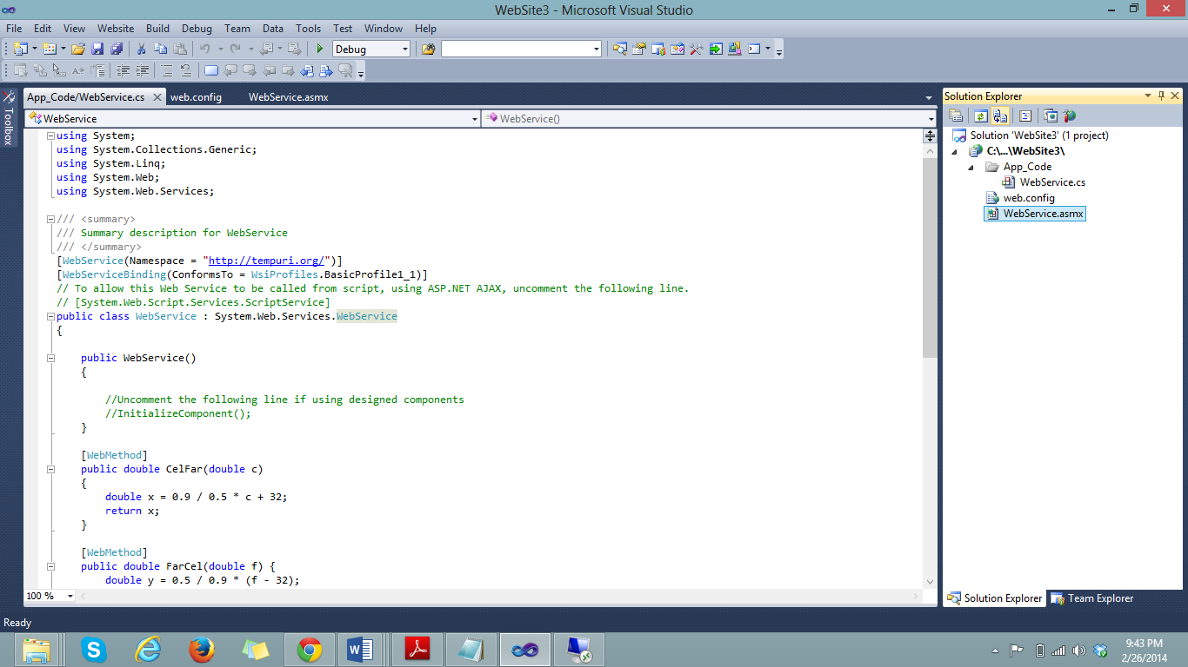

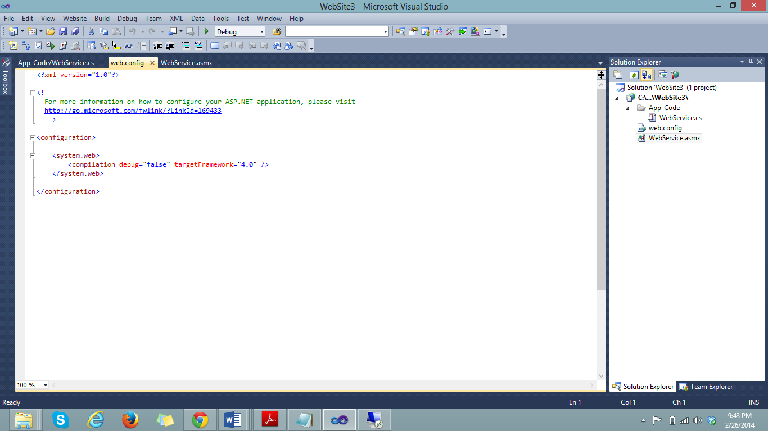

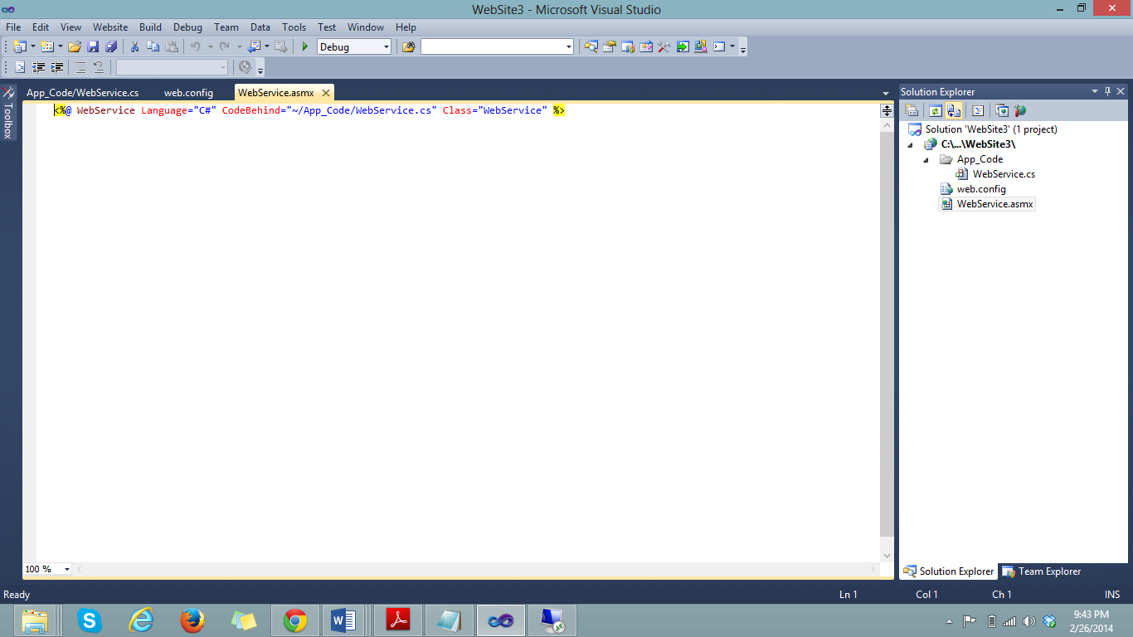

1. The .asmx file has to be opened in browser as shown.

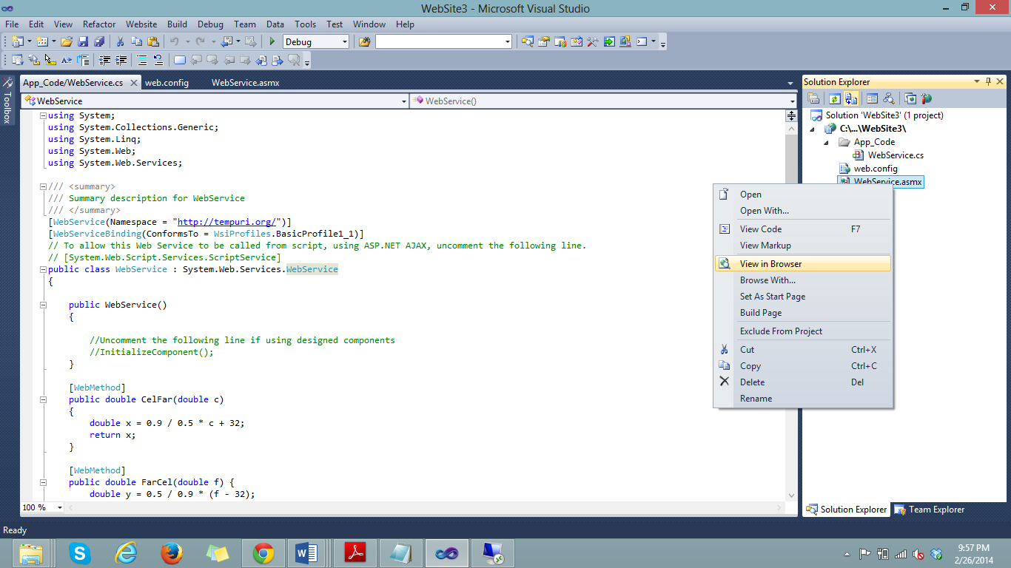

1. It will open in browser as shown. The services are shown in the page.

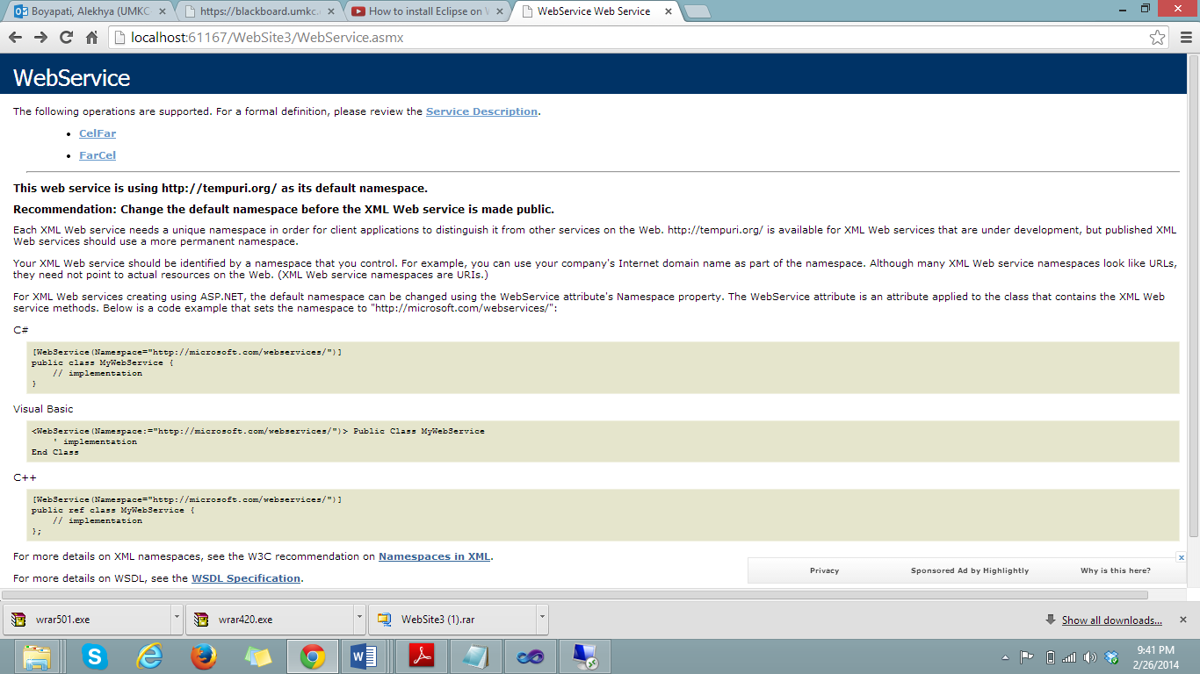

1. When the service description tab is clicked the following window will appear.

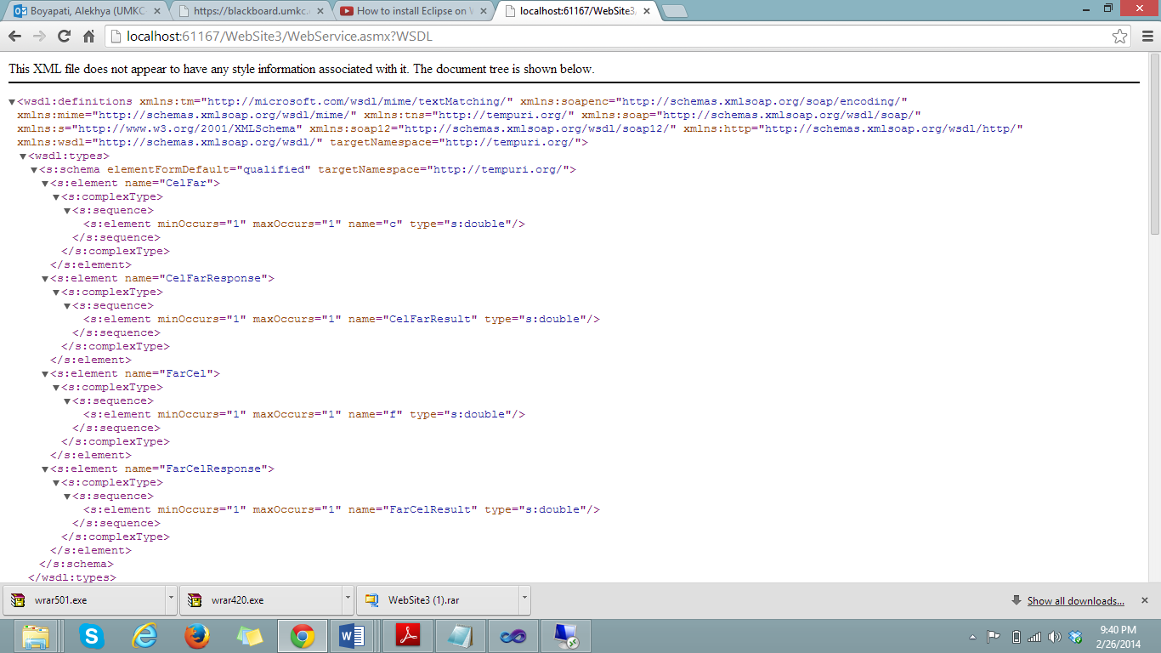

1. First I am selecting the “CelFar” tab which converts temperatures from Celsius to Fahrenheit.

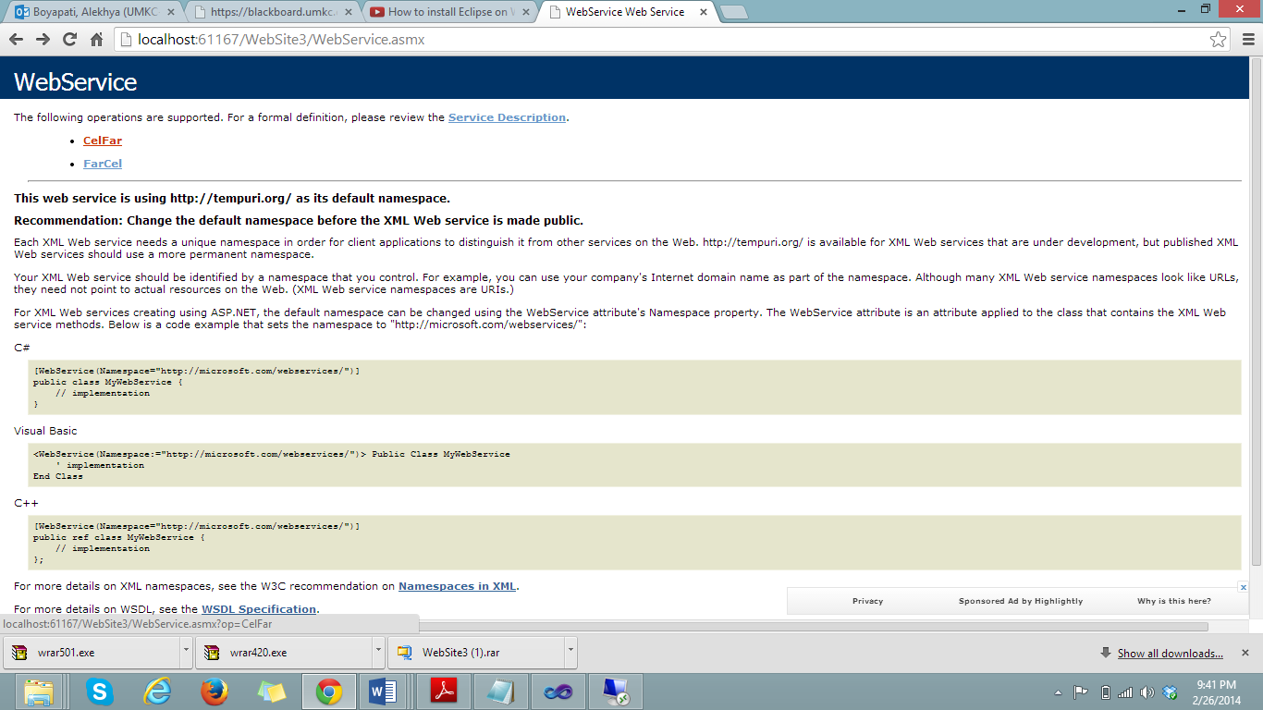

1. Here it will ask to enter the Celsius temperature that needs to be converted to Fahrenheit. I entered 12∙C and clicked the invoke tab.

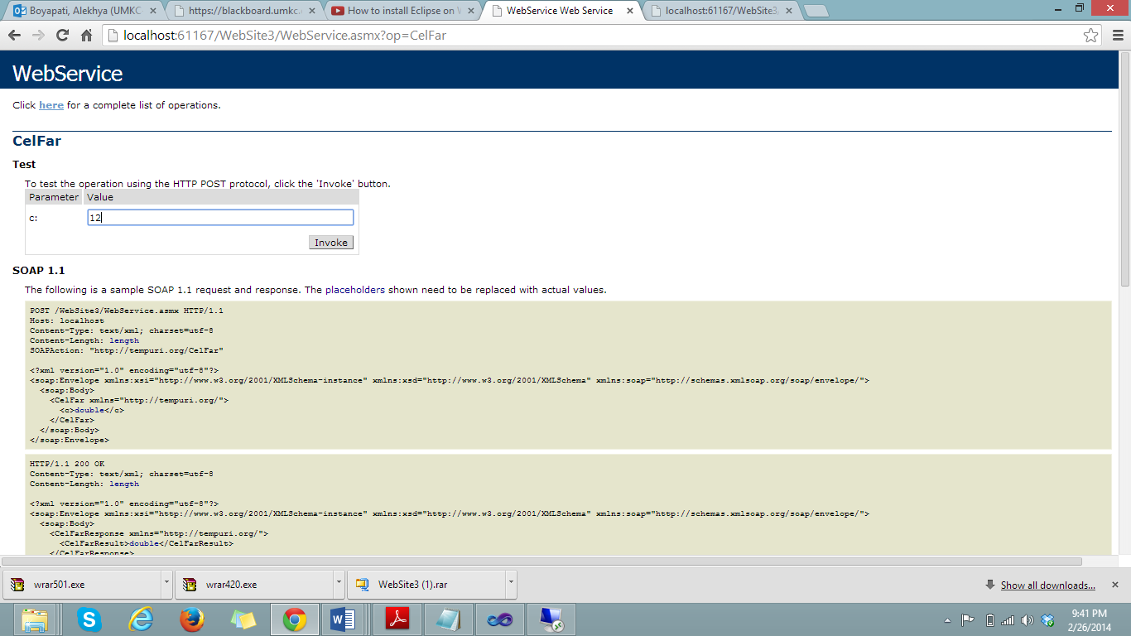

1. The Fahrenheit temperature is shown below as 53.6

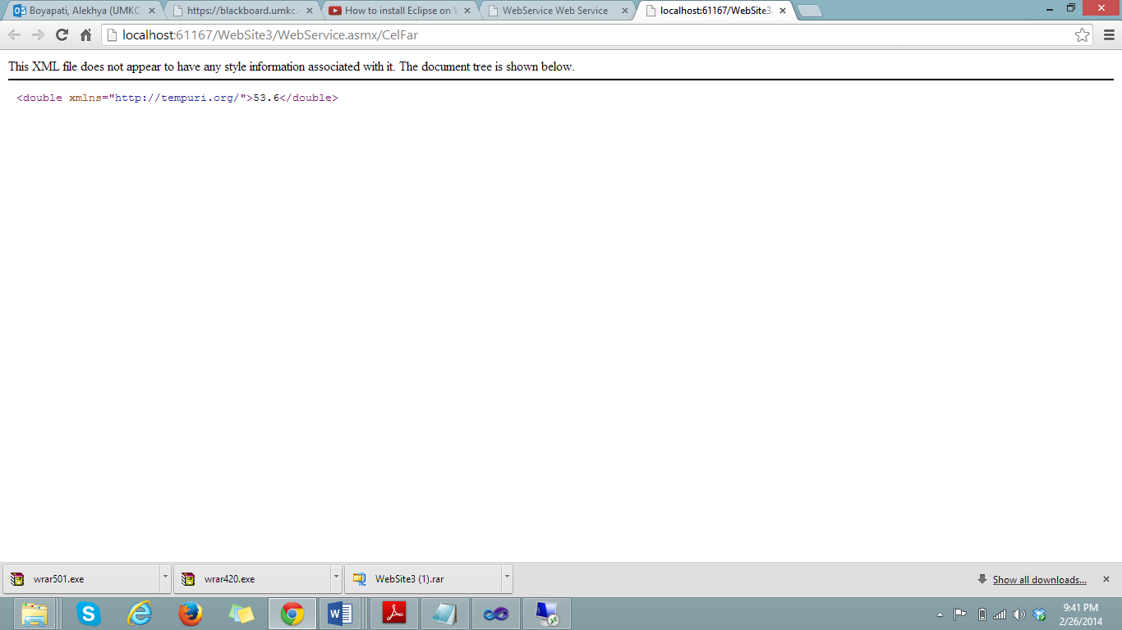

1. Next the “FarCel” tab is selected to convert Fahrenheit to Celsius. Here temperature in Fahrenheit has to be entered and I entered 53.6 ∙F.

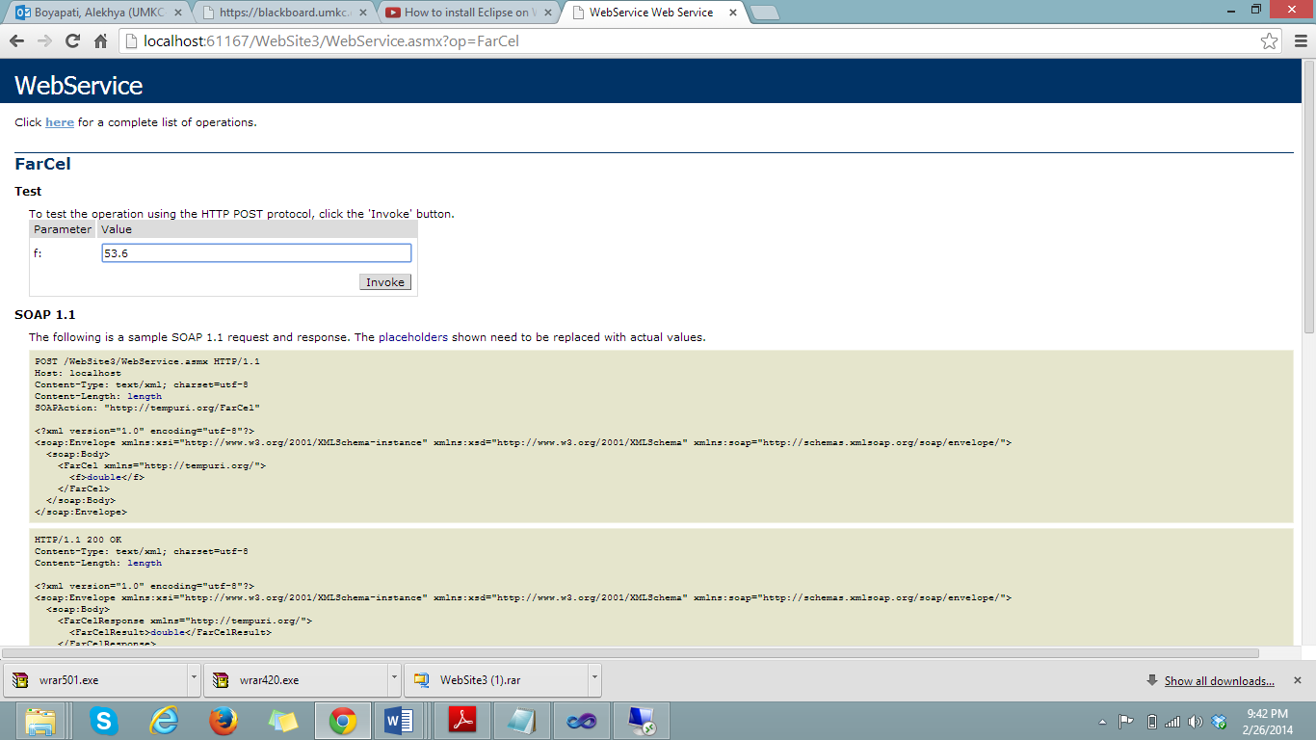

1. The temperature in Celsius has been displayed as 12∙C

